Bulletin Filler documentation

This document will overview the necessary information to successfully run and use the Bulletin Filler script to fill in required data for the monthly Water Levels Bulletin.

# Note:

The code is very sensitive to the formatting of excel files and data files. The program should have informative error messages for each one of these, however, most issues will be because a cell is in the wrong place or an excel sheet is named incorrectly, etc.

**This script is meant to be used in tandem with the regular Monthly Bulletin Creation process** (documentation is “UPDATED 2002-02-01 Bulletin Creation.docx” found in I:\Tides\BULLETIN\Procedure\Updated QMS)

# Procedure:

## Setup:

1. Navigate to the Bulletin Filler folder found in I:\Tides\BULLETIN\Bulletin Filler. There, you will find a folder named BulletinFiller_final. Copy and paste this folder onto your desktop or any local directory.
2. Once copied to your local directory, open the BulletinFiller_final.exe found in the folder.

## Use:

1. 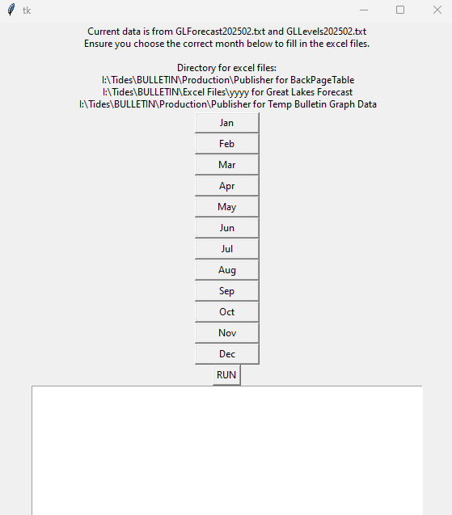After you have completed the setup, the following UI should open after a short wait:
2. Usage is very simple, select the month for the Bulletin you’re currently making (i.e: if it’s February you are making the January bulletin so select Jan) and click “RUN”.
3. 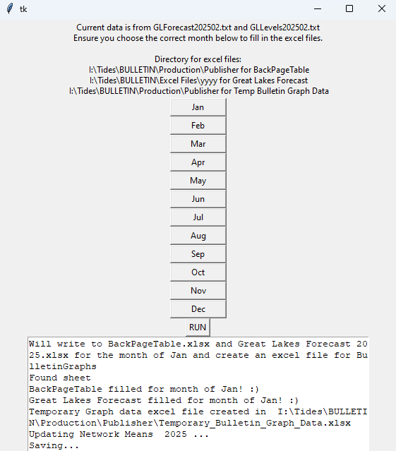After pressing “RUN” the UI should look like this:

**Note**: The program will actually open the Network Means yyyy.xlsm file. This is necessary as it’s a .xlsm type file. The monthly mean for each lake should be filled for the current month.

1. The program is finished running and you can close the window! Consult the Bulletin documentation for the next steps. **If help is required for the temporary bulletin graph data usage, see below.** There is also instructions for using the program in the bulletin documentation which should help show you what has and hasn’t been done by the program.

## Summary of Operations:

This program automatically completes 4 tasks:

1. Fills the “BackPageTable.xlsx” file found in I:\Tides\BULLETIN\Production\Publisher for the current month. You are still required to copy and paste it over to the “For Publisher” tab in the excel file.
2. Fills the “Temporary_Bulletin_Graph_Data.xlsx” found in I:\Tides\BULLETIN\Production\Publisher. Documentation on how to use this file is found below.
3. Updates the Network Means yyyy.xlsx file found in I:\Tides\Great Lakes Network Means\yyyy.
4. Fills the Great Lakes Forecast yyyy.xlsx file found in I:\Tides\BULLETIN\Excel Files\yyyy.

Ensure that the correct data is in these excel files by referencing the forecast files in I:\Tides\BULLETIN\Forecast Files\yyyy.

Utilize this script to skip the data entry part of the Monthly Bulletin creation.

## Temporary Bulletin Graphs help:

1. Open the “Temporary_Bulletin_Graph_Data.xlsx” found in I:\Tides\BULLETIN\Production\Publisher. The excel sheet should look like this: 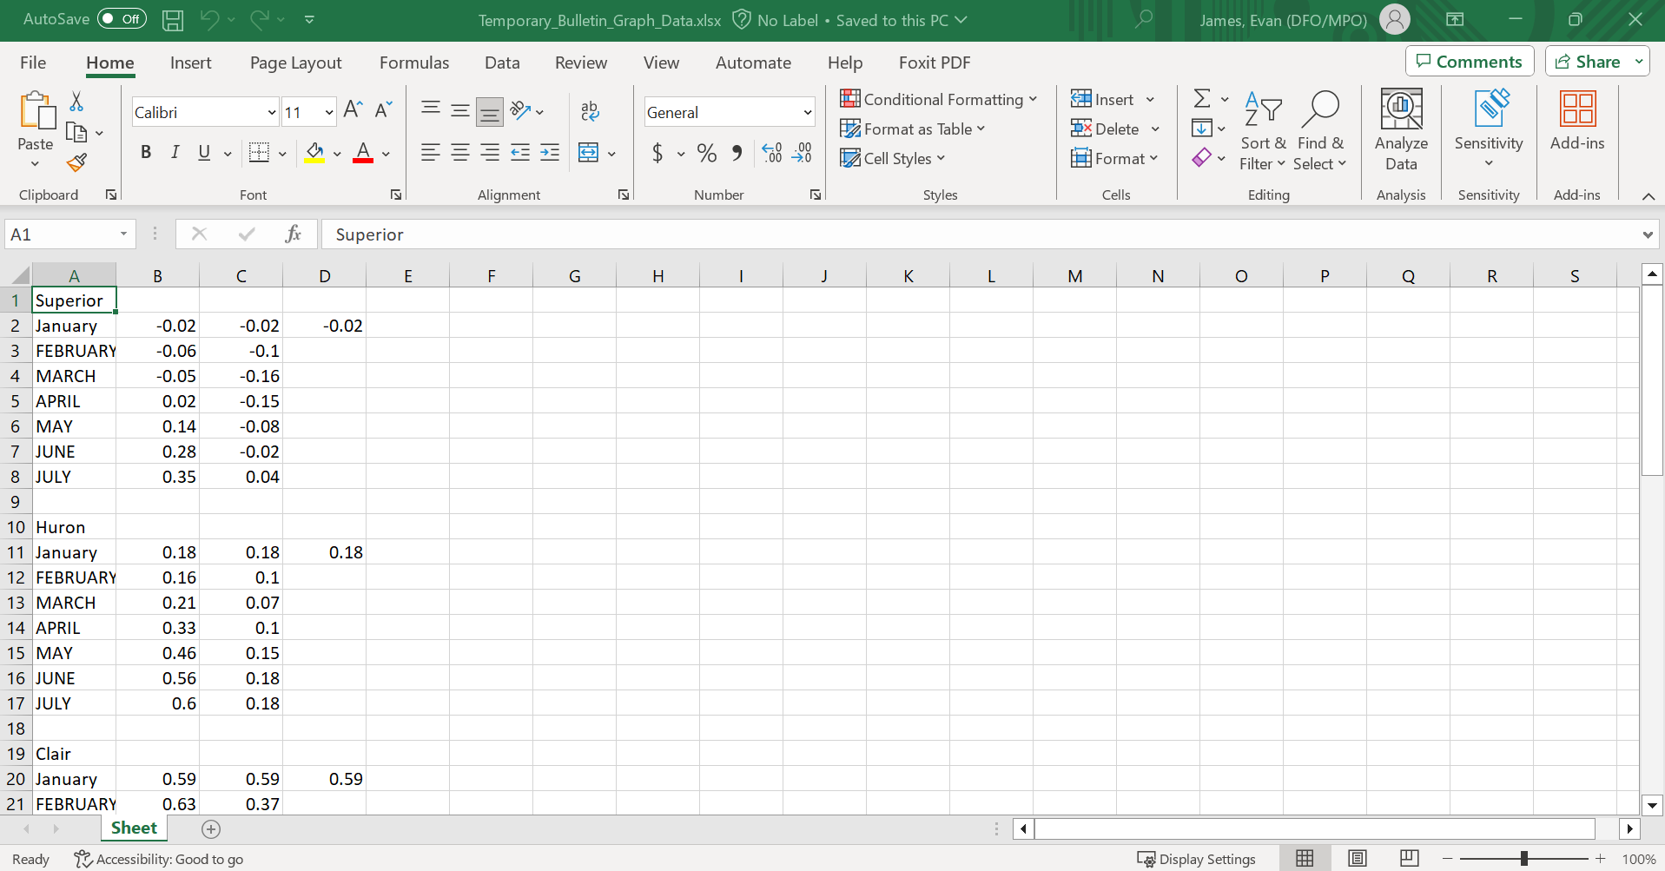

Each block of data represents the data we enter into the Bulletin Graphs excel sheet for each lake.

1. Open “BulletinGraphs.xlsx” also found in I:\Tides\BULLETIN\Production\Publisher. We’re focusing on the sheets named “Lake name_Data”.

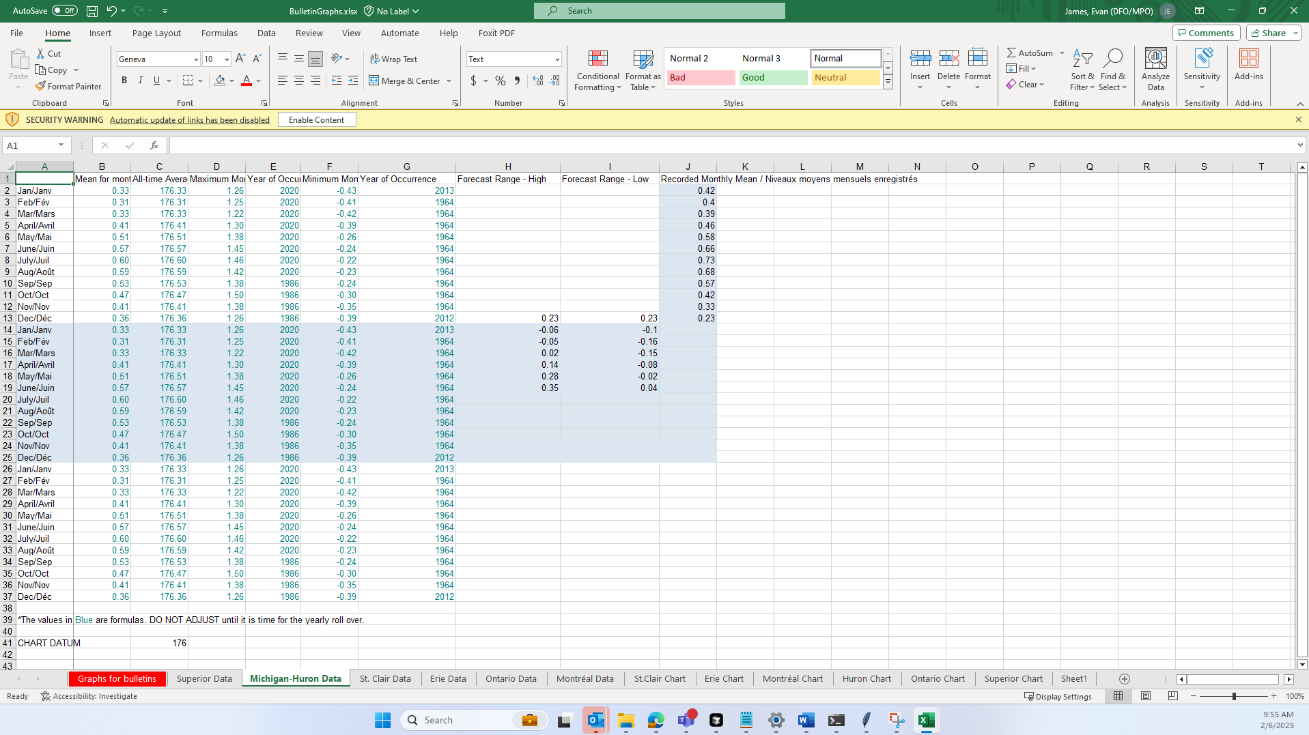

1. Remove the data currently in the Forecast Range – High and Low columns and insert the data for the current lake from the temporary file. Ensure you match up the months correctly.

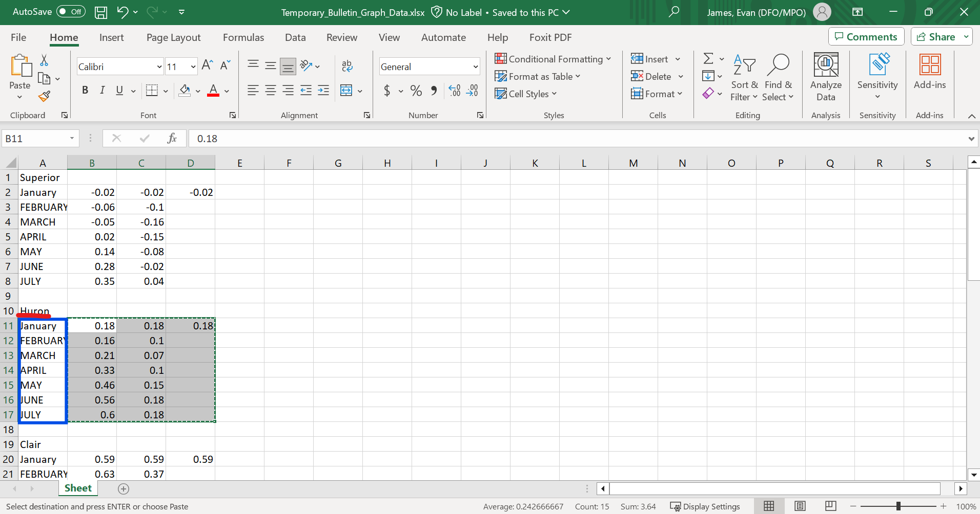

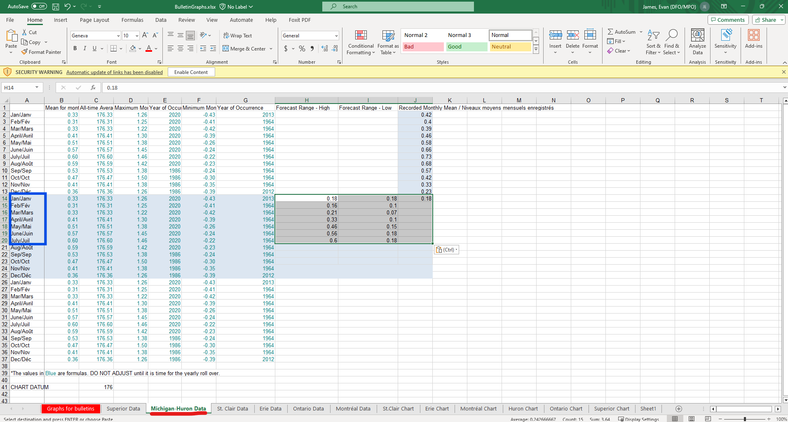

1. Recolour the edited cells to match the style and repeat this process for every lake.